Vladimir Pejović, Jiwon Lee, Epimitheas Georgitzikis, Yunlong Li, Joo Hyoung Kim, Itai Lieberman, Paweł E. Malinowski, Paul Heremans, and David Cheyns

Thin-Film Photodetector Optimization for High-Performance Short-Wavelength Infrared Imaging
Abstract—In this paper, we present a small pixel pitch image sensor optimized for high external quantum efficiency in short-wavelength infrared (SWIR). Thin-film photodiodes based on PbS colloidal quantum dot (CQD) absorber allow us to exceed the spectral limitations of silicon’s absorption while maintaining the benefits of CMOS technology. By monolithically integrating PbS CDQ thin films with CMOS readout arrays, high-pixel density SWIR image sensors can be achieved. To overcome the remaining disadvantages of the CQD-based image sensors over their bulk III-V semiconductor counterparts (lower sensitivity and reduced linearity), the thin-film photodiode stack is adapted towards the used readout circuit. A prototype image sensor with a 768x512 resolution of 5-µm pitch pixels is fabricated by using a modified 130 nm CMOS process for readout IC, together with the new CQD thin-film photodiode on top. Thanks to the optimized photodiode stack and co-integration process, the prototype image sensor shows less than 5% linearity error while having 40% external quantum efficiency in SWIR, which enables acquisition of high-quality images.
Index Terms—SWIR Image Sensor, High-Resolution Infrared Imaging, Thin-Film Photodetectors, Colloidal Quantum Dots

Introduction
S
HORT-wavelength infrared (SWIR) refers to the region of the electromagnetic spectrum with wavelengths between 1 and 2.5 μm. Imaging in this spectral range is relevant for industries such as agriculture, machine vision (e.g. sorting and recycling), surveillance (e.g. low-light vision), identification of biomolecules, and others. SWIR imagers are usually based on III-V semiconductors such as InGaAs. Due to the high cost and low throughput of III-V device production, as well as complex flip-chip hybridization process with CMOS, InGaAs-based image sensors are expensive compared to CMOS image sensors (CIS), which prevents their deployment across a wider range of industries. Moreover, their performance has been improving at a slow pace, with the low resolution being one of the most critical drawbacks. For decades, the pixel pitch was limited to 10 μm and above, and only recently it was reduced to 5 μm by an advanced bonding technology [1].
Several rapidly growing fields such as machine vision and consumer devices (AR/VR) are showing high interest in affordable SWIR imaging systems. As a result, new technologies that intend to combine good imaging quality, scalability of pixel size and upscalability of the technology are emerging. Thin-film photodetectors based on colloidal quantum dots (CQD), processed as films on top of a CMOS readout circuit (ROIC), are promising candidates to achieve this goal [2]–[4].
CQDs are chemically synthesized spherical nanocrystals which are characterized by tunability of the optical properties. Thanks to the quantum confinement effect, the size of CQDs determines their absorption and emission spectra, with larger dots emitting and absorbing longer wavelengths. After the synthesis, CQDs are dispersed in a solvent, which enables room-temperature deposition of this material on any wafer size using spin-coating. This results in a possibility of direct (monolithic) integration of CQD-based photodetectors on readout electronics on a wafer scale, unlike III-V photodetector arrays that require epitaxy, limited to small wafer sizes, and flip-chip hybridization with ROIC.
A wide range of photodetectors employing CQDs for infrared sensing was demonstrated in the literature, including photoconductors, phototransistors, and photodiodes [5], [6]. Significant progress in CQD devices was made over the past decade, which enabled photodiodes with impressively high external quantum efficiency (EQE) of 80% in SWIR [7]–[9]. However, the progress was mainly driven by photovoltaic applications, which left the issue of the dark current largely neglected and unreported. The high dark current of CQD photodiodes, originating from abundant trap states, is detrimental to image sensor performance. This issue can be mitigated by applying a low bias voltage during signal readout, in the range of several mV [10]. Another class of photodetectors that was exploited for imaging is a phototransistor based on CQDs and graphene [11], [12]. It relies on a photogating effect and induced gain, leading to a high responsivity of 10⁷ AW⁻¹. Despite their promise for SWIR imaging, both approaches demand complex readout schemes that require a large chip footprint, which limits the image sensor’s pixel pitch. Hence, these image sensors do not fully exploit the potential of CQDs. Recently, it was demonstrated that CQD thin-film technology, in combination with a simpler ROIC, can outperform InGaAs focal plane arrays (FPAs) in terms of resolution, with pixel pitch below 2 μm [2]. However, the non-linear output and relatively low EQE of the used photodetector pose a serious limitation to its application.
In this paper, we present an image sensor with low linearity error and high EQE of 40% in SWIR, based on a photodetector design optimized for high pixel density ROICs. This work demonstrates an imaging solution that can effectively surpass the limitations of InGaAs FPAs and has the potential to become a new standard for SWIR imaging in the future.

Operation Principle
For this work, we used PbS CQDs which can be tuned to absorb SWIR wavelengths. This material has been widely explored for applications in thin-film solar cells [13], photodetectors [5], [6], and LEDs [14]. Fig. 1 (a) shows a transmission electron microscopy (TEM) image of our PbS CQD photodiode stack integrated on a CMOS ROIC. The top electrode is a transparent metal oxide such as indium tin oxide (ITO) that allows light penetration into the absorber. The bottom electrode is made of a highly reflective metal that enhances light absorption in the CQD layer by reflecting the incoming light back to the device. The active PbS CQD layers are separated from the electrodes by electron (ETL) and hole (HTL) transport layers.
To maximize the scaling capability enabled by thin-film technology, we chose a 3T pixel readout architecture as shown in Fig 1 (b) [15], rather than a capacitive trans-impedance amplifier (CTIA) pixel, preferred for InGaAs image sensors for its fixed bias operation, which usually includes one capacitor and two amplifiers, reset, row selector transistor and current source [16]–[19]. The 3T pixel, on the other hand, contains minimal in-pixel components: reset transistor (RST), source follower (SF), and row select (SEL) transistor (Fig. 1 (b)). For a pixel that collects electrons, the signal electrons are read from the cathode while the anode is shared among the entire array of pixels (for hole collection, cathode is shared, and anode is read). After resetting the PD, in case of electron collection, the collected electrons reduce the cathode node voltage proportional to the illumination and integration time. To be able to read the signal with reasonable dynamic range, an integration node voltage swing between a few hundreds of mV to around 1V is usually required. To keep the pixel output linear, the photodiode response should be constant within the photodiode voltage swing.
(a) (b)
Fig. 1. (a) TEM image of a PbS CQD stack and (b) stack integration on a ROIC

Photodetector Optimization
First, we fabricated and characterized test photodiodes with an active area of 0.13 cm². CQDs with a 5.4 nm diameter were used, which corresponds to a bandgap of 0.86 eV. All the layers were spin-coated on 3x3 cm² substrates and a solid-phase ligand exchange step was applied to the CQD films [20], [21]. TiO₂ nanoparticles were used as ETL and a semiconductor polymer PolyTPD as HTL.
A critical step during the fabrication is to passivate the surface of CQDs, which is done by molecules which act as ligands. Initially, long organic molecules bind to CQDs to enable their dispersion in organic solvents. Due to their length, these ligands hinder charge carrier transport, and it is necessary to replace them with shorter ones to increase the film’s conductivity. The choice of new ligands determines the properties of CQD films such as doping, mobility, and trap state density [22], [23].
Two designs of PbS CQDs photodiodes are explored in this paper. The main building block of the first generation, here referred to as “gen1”, is a heterojunction created by a wide bandgap n-type ETL, typically made of ZnO or TiO2, and a p-type CQD film [21], [24]. This design was a basis in our previous work [2], [25]. The built-in field at the interface between these two materials serves to separate photogenerated carriers, as illustrated in the band diagram in Fig. 2 (a). Short organic molecules are typically used as ligands to obtain p-type behavior [22].
IV and EQE vs bias voltage curves measured at room temperature are shown in Fig. 3 (a) and 3 (b), respectively. Gen1 photodiode exhibits low dark current density of 20 nA/${cm}^{2}$ at -1 V. However, the EQE is limited to only 12%, and a strong bias voltage dependency is observed, which is an unwanted behavior for 3T pixel design. Interestingly, after the device is exposed to UV light, the EQE increases and saturates at -1.5 V. This phenomenon can be explained by photodoping of TiO₂ by UV, which was observed in PbS solar cells [26]. By increasing the electron density in TiO₂, the built-in field over the active layer increases, and the depletion region shifts to the absorber’s side, which leads to a more efficient carrier extraction. However, this effect is temporary, and it negatively affects the dark current. Despite its low dark current, we conclude that the gen1 approach has some inherent disadvantages for realizing pixels that employ 3T structure, not only due to the low EQE, but also due to its non-saturated response that introduces non-linearity in the image sensor’s output.

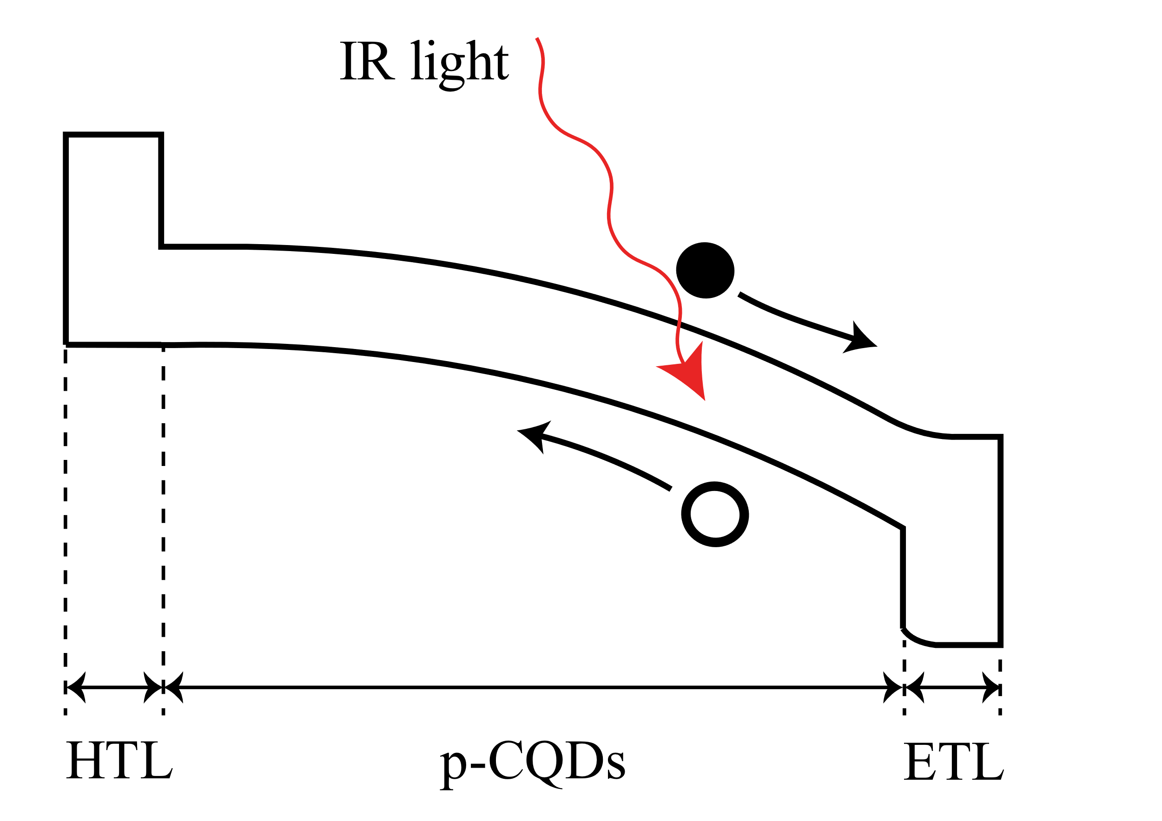
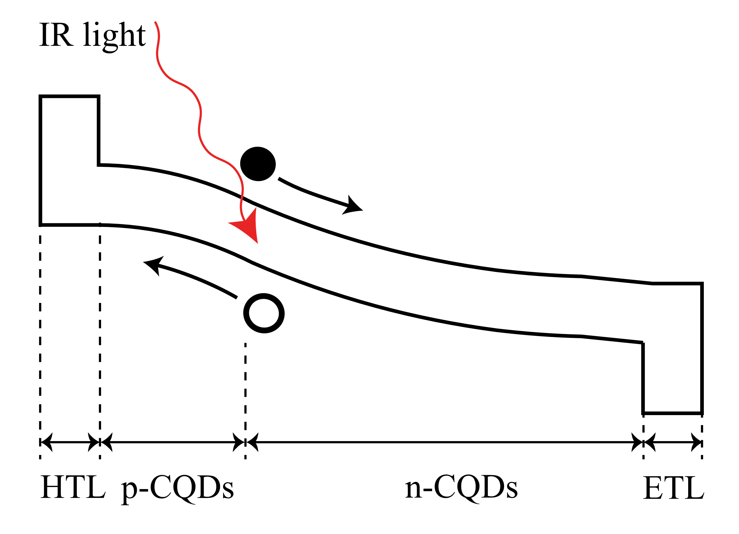

(a) (b)
Fig. 2. Illustrated band diagrams under reverse bias of (a) gen1 and (b) gen2 PbS-based photodiodes
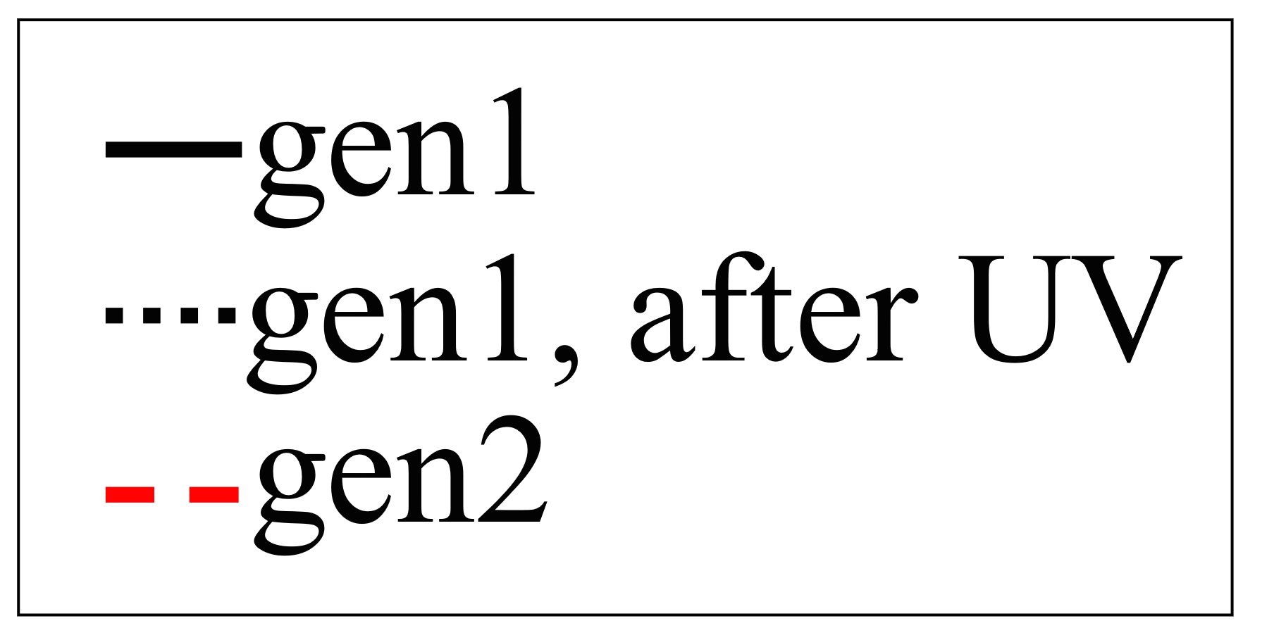

(a) (b)
Fig. 3. Device characterization: (a) IV curve and (b) EQE versus bias voltage under SWIR illumination of gen1 and gen2 PbS-based photodiodes
To solve the issue of low EQE and non-saturated response, we adopt the second generation (gen2) photodiode design that provides a possibility to use thicker CQD absorbers and hence increase light absorption. Gen2 is based on a homojunction, created by two distinct types of CQD films: a thin p-layer, and a thicker, newly introduced n-layer obtained by using inorganic ions as ligands. Gen2 band diagram is illustrated in Fig. 2 (b). Shorter inorganic ligands significantly improve the properties of CQD films, mainly the carrier mobility, which increases carrier diffusion length and allows deposition of thicker absorbers [27], [28]. A stable EQE of more than 40% was measured, for a voltage region between -4 V and -1.5 V, suitable for signal integration by 3T pixel structure. This behavior indicates that the homojunction created by different ligands is better in separating electron-hole pairs and it does not rely on external UV activation. However, the gen2 device exhibits higher dark current density of 790 nA/${cm}^{2}$ at -1 V bias. The gen1 device performs better in this respect partially because of the higher resistivity that is associated with p-type CQD PbS films [29], [30]. In addition, formation of trap states in the absorber, which heavily depends on the used ligands, inevitably affects the dark current, and this issue will be our focus point in the future. Nevertheless, we obtain a high detectivity of 9.5x10¹¹ Jones for gen2 device, assuming a shot-noise dominated operation.
It should be noted that EQE of up to 80% can be reached by PbS CQDs, as shown by several thin-film photovoltaic research groups [7]–[9]. However, the accompanying dark current is either not reported, or it is very high, which increases the noise caused by the external bias voltage, required for 3T pixel operation. We believe that the EQE reported in this paper can be further increased by absorption enhancement via optical engineering, without compromising the dark current.

High EQE CQD Image Sensor
A prototype image sensor was fabricated by using a 130 nm CMOS process optimized for co-integration together with the developed photodiode stacks. The designed image sensor contains 768x512 pixel array with a 5 µm pixel pitch. Pixel outputs are buffered and serially multiplexed on chip, then digitized by on-board 16-bit analog-to-digital converter (ADC).
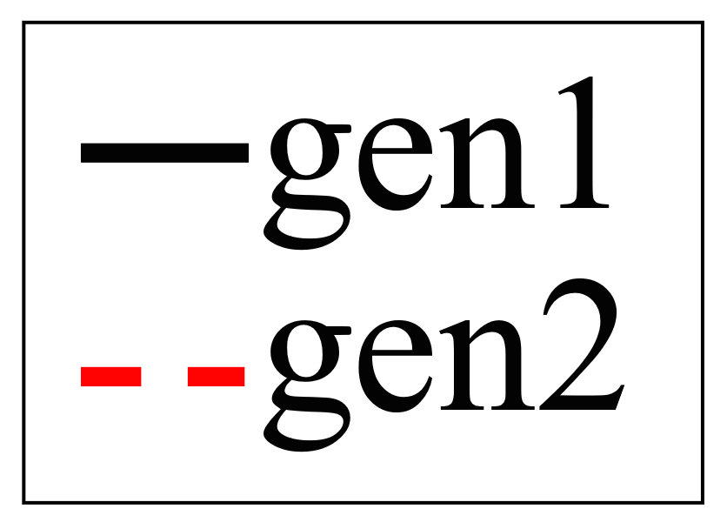

(a) (b)
Fig. 4. Image sensor characterization: (a) linearity error and (b) EQE versus wavelength of image sensors with gen1 and gen2 PbS-based photodiodes
Fig. 4 (a) shows the measured linearity of image sensors with photodiodes of both generations. Output curve is fitted from 10% to 60% and the deviation from the ideal curve is calculated [31]. As expected from the test photodiodes, the image sensor with the gen2 photodiode shows better linearity with less than 5% linearity error in the entire operating range. The sudden linearity drop above 50,000 DN (digital number) is due to pixel saturation. Similarly, the measured EQE shown in Fig. 4 (b) matches well the results obtained from the test photodiodes, with 40% EQE in SWIR achieved by gen2. To the best of the authors’ knowledge, this is the highest EQE SWIR image sensor using CQD photodiodes ever reported. In addition to the high EQE and linear photodiode output, thanks to the adaption of dual conversion gain function, high full well capacity (FWC) could be achieved while keeping the read noise low, which would eventually improve the quality of the captured images. Photo responsivity non-uniformity (PRNU) is measured to be 2.4%, which proves that photodiode uniformity is properly controlled while processing the new photodiode stack. Clear images could be captured by our prototype image sensor with gen2 photodiode stack, as shown in Fig. 5, under SWIR and visible illumination. The two plastic plates made of different materials show clear differences under SWIR, whereas both are black under visible light. Table 1. summarizes the performance of our image sensor in comparison with state-of-the-art results.

(a) (b)
Fig. 5. Sample captured by gen2 PbS image sensor under (a) visible light and (b) SWIR
TABLE I
Performance summary of state-of-the-art technologies

Conclusion
In this paper, we analyzed the requirements for monolithic integration of thin-film photodiodes with high pixel density CMOS readout circuit. We optimized PbS quantum dots photodiode to be compatible with a 3T pixel design, which opens a path for the realization of SWIR image sensors with resolution beyond the current state-of-the-art. We presented a SWIR image sensor with 768x512 pixel array, pixel pitch of 5 µm with 40% EQE at 1450 nm. Co-optimization of the photodiode stack and the readout allow us to acquire images with high sensitivity and high level of detail. These results demonstrate the potential of the thin-film technology to enable new emerging applications in SWIR imaging.
REFERENCES

[1] S. Manda, Y. Zaizen, T. Hirano, H. Iwamoto, R. Matsumoto, S. Saito, S. Maruyama, H. Minari, T. Hirano, T. Takachi, N. Fujii, and Y. Yamamoto, “High-definition Visible-SWIR InGaAs Image Sensor using Cu-Cu Bonding of III-V to Silicon Wafer.,” in Technical Digest - International Electron Devices Meeting, IEDM, 2019, vol. 2019-December, doi: 10.1109/IEDM19573.2019.8993432.
[2] J. Lee, E. Georgitzikis, Y. Li, Z. Lin, J. Park, I. Lieberman, D. Cheyns, A. Lambrechts, S. Thijs, R. Stahl, and P. E. Malinowski, “Imaging in Short-Wave Infrared with 1 . 82 µm Pixel Pitch Quantum Dot Image Sensor,” IEEE Int. Electron Devices Meet., pp. 343–346, 2020, doi: 10.1109/IEDM13553.2020.9372018.
[3] L. Barrow, N. Bock, A. Bouvier, D. Clocchiatti, J. Feng, N. Kolli, A. Pattantyus, V. Sharma, T.-H. Shu, and E. Mandelli, “A Quantum Film based QuadVGA 1.5µm pixel image sensor with over 40% QE at 940 nm for actively illuminated applications,” Iisw, 2017.
[4] SWIR Vision Systems, “Acuros CQD 1920/1920L GigE SWIR Camera.” https://www.swirvisionsystems.com/wp-content/uploads/Acuros-CQD-1920L-GigE-SWIR-Camera_003.pdf.
[5] R. Saran and R. J. Curry, “Lead sulphide nanocrystal photodetector technologies,” Nature Photonics, vol. 10, no. 2. pp. 81–92, 2016, doi: 10.1038/nphoton.2015.280.
[6] X. Yin, C. Zhang, Y. Guo, Y. Yang, Y. Xing, and W. Que, “PbS QD-based photodetectors: Future-oriented near-infrared detection technology,” J. Mater. Chem. C, vol. 9, no. 2, 2021, doi: 10.1039/d0tc04612d.
[7] Y. Bi, S. Pradhan, S. Gupta, M. Z. Akgul, A. Stavrinadis, and G. Konstantatos, “Infrared Solution-Processed Quantum Dot Solar Cells Reaching External Quantum Efficiency of 80% at 1.35 µm and Jsc in Excess of 34 mA cm−2,” Adv. Mater., vol. 30, no. 7, 2018, doi: 10.1002/adma.201704928.
[8] J. Z. Fan, N. T. Andersen, M. Biondi, P. Todorović, B. Sun, O. Ouellette, J. Abed, L. K. Sagar, M. J. Choi, S. Hoogland, F. P. G. de Arquer, and E. H. Sargent, “Mixed Lead Halide Passivation of Quantum Dots,” Adv. Mater., vol. 31, no. 48, 2019, doi: 10.1002/adma.201904304.
[9] M. Vafaie, J. Z. Fan, A. Morteza Najarian, O. Ouellette, L. K. Sagar, K. Bertens, B. Sun, F. P. García de Arquer, and E. H. Sargent, “Colloidal quantum dot photodetectors with 10-ns response time and 80% quantum efficiency at 1,550 nm,” Matter, vol. 4, no. 3, pp. 1042–1053, 2021, doi: 10.1016/j.matt.2020.12.017.
[10] E. J. D. Klem, C. Gregory, D. Temple, and J. Lewis, “PbS colloidal quantum dot photodiodes for low-cost SWIR sensing,” in Infrared Technology and Applications XLI, 2015, vol. 9451, doi: 10.1117/12.2178532.
[11] G. Konstantatos, M. Badioli, L. Gaudreau, J. Osmond, M. Bernechea, F. P. G. De Arquer, F. Gatti, and F. H. L. Koppens, “Hybrid graphene quantum dot phototransistors with ultrahigh gain,” Nat. Nanotechnol., vol. 7, no. 6, 2012, doi: 10.1038/nnano.2012.60.
[12] S. Goossens, G. Navickaite, C. Monasterio, S. Gupta, J. J. Piqueras, R. Pérez, G. Burwell, I. Nikitskiy, T. Lasanta, T. Galán, E. Puma, A. Centeno, A. Pesquera, A. Zurutuza, G. Konstantatos, and F. Koppens, “Broadband image sensor array based on graphene-CMOS integration,” Nat. Photonics, vol. 11, no. 6, 2017, doi: 10.1038/nphoton.2017.75.
[13] J. Tang and E. H. Sargent, “Infrared colloidal quantum dots for photovoltaics: Fundamentals and recent progress,” Adv. Mater., vol. 23, no. 1, pp. 12–29, 2011, doi: 10.1002/adma.201001491.
[14] S. Pradhan, F. Di Stasio, Y. Bi, S. Gupta, S. Christodoulou, A. Stavrinadis, and G. Konstantatos, “High-efficiency colloidal quantum dot infrared light-emitting diodes via engineering at the supra-nanocrystalline level,” Nat. Nanotechnol., vol. 14, no. 1, pp. 72–79, 2019, doi: 10.1038/s41565-018-0312-y.
[15] E. R. Fossum, “Active pixel sensors: are CCD’s dinosaurs?,” Proceedings.of the.SPIE - The.International Soc., vol. 1900, 1993.
[16] B. A. Fowler, J. Balicki, D. How, and M. Godfrey, “Low-FPN high-gain capacitive transimpedance amplifier for low-noise CMOS image sensors,” in Sensors and Camera Systems for Scientific, Industrial, and Digital Photography Applications II, 2001, vol. 4306, doi: 10.1117/12.426991.
[17] S. Eminoglu, M. Isikhan, N. Bayhan, M. A. Gulden, O. S. Incedere, S. T. Soyer, S. Kocak, G. S. Yilmaz, and T. Akin, “MT6415CA: a 640×512-15µm CTIA ROIC for SWIR InGaAs detector arrays,” in Infrared Technology and Applications XXXIX, 2013, vol. 8704, doi: 10.1117/12.2019519.
[18] H. Figgemeier, M. Benecke, K. Hofmann, R. Oelmaier, A. Sieck, J. Wendler, and J. Ziegler, “SWIR detectors for night vision at AIM,” in Infrared Technology and Applications XL, 2014, vol. 9070, doi: 10.1117/12.2050320.
[19] M. MacDougal, J. Geske, C. Wang, and D. Follman, “Low-Light-Level InGaAs focal plane arrays with and without illumination,” in Infrared Technology and Applications XXXVI, 2010, vol. 7660, doi: 10.1117/12.852605.
[20] G. Konstantatos, J. Clifford, L. Levina, and E. H. Sargent, “Sensitive solution-processed visible-wavelength photodetectors,” Nat. Photonics, vol. 1, no. 9, pp. 531–534, 2007, doi: 10.1038/nphoton.2007.147.
[21] D. Zhitomirsky, O. Voznyy, L. Levina, S. Hoogland, K. W. Kemp, A. H. Ip, S. M. Thon, and E. H. Sargent, “Engineering colloidal quantum dot solids within and beyond the mobility-invariant regime,” Nat. Commun., vol. 5, 2014, doi: 10.1038/ncomms4803.
[22] O. Voznyy, D. Zhitomirsky, P. Stadler, Z. Ning, S. Hoogland, and E. H. Sargent, “A charge-orbital balance picture of doping in colloidal quantum dot solids,” ACS Nano, vol. 6, no. 9, pp. 8448–8455, 2012, doi: 10.1021/nn303364d.
[23] A. H. Ip, S. M. Thon, S. Hoogland, O. Voznyy, D. Zhitomirsky, R. Debnath, L. Levina, L. R. Rollny, G. H. Carey, A. Fischer, K. W. Kemp, I. J. Kramer, Z. Ning, A. J. Labelle, K. W. Chou, A. Amassian, and E. H. Sargent, “Hybrid passivated colloidal quantum dot solids,” Nat. Nanotechnol., vol. 7, no. 9, pp. 577–582, 2012, doi: 10.1038/nnano.2012.127.
[24] B. N. Pal, I. Robel, A. Mohite, R. Laocharoensuk, D. J. Werder, and V. I. Klimov, “High-Sensitivity p-n junction photodiodes based on Pbs nanocrystal quantum dots,” Adv. Funct. Mater., vol. 22, no. 8, pp. 1741–1748, 2012, doi: 10.1002/adfm.201102532.
[25] E. Georgitzikis, P. E. Malinowski, J. Maes, A. Hadipour, Z. Hens, P. Heremans, and D. Cheyns, “Optimization of Charge Carrier Extraction in Colloidal Quantum Dots Short-Wave Infrared Photodiodes through Optical Engineering,” Adv. Funct. Mater., vol. 28, no. 42, 2018, doi: 10.1002/adfm.201804502.
[26] J. Choi, J. W. Jo, F. P. G. de Arquer, Y. B. Zhao, B. Sun, J. Kim, M. J. Choi, S. W. Baek, A. H. Proppe, A. Seifitokaldani, D. H. Nam, P. Li, O. Ouellette, Y. Kim, O. Voznyy, S. Hoogland, S. O. Kelley, Z. H. Lu, and E. H. Sargent, “Activated Electron-Transport Layers for Infrared Quantum Dot Optoelectronics,” Adv. Mater., vol. 30, no. 29, 2018, doi: 10.1002/adma.201801720.
[27] D. Zhitomirsky, M. Furukawa, J. Tang, P. Stadler, S. Hoogland, O. Voznyy, H. Liu, and E. H. Sargent, “N-type colloidal-quantum-dot solids for photovoltaics,” Adv. Mater., vol. 24, no. 46, 2012, doi: 10.1002/adma.201202825.
[28] C. H. M. Chuang, P. R. Brown, V. Bulović, and M. G. Bawendi, “Improved performance and stability in quantum dot solar cells through band alignment engineering,” Nat. Mater., vol. 13, no. 8, pp. 796–801, 2014, doi: 10.1038/nmat3984.
[29] M. A. Boles, D. Ling, T. Hyeon, and D. V. Talapin, “The surface science of nanocrystals,” Nature Materials, vol. 15, no. 2. pp. 141–153, 2016, doi: 10.1038/nmat4526.
[30] R. Wang, Y. Shang, P. Kanjanaboos, W. Zhou, Z. Ning, and E. H. Sargent, “Colloidal quantum dot ligand engineering for high performance solar cells,” Energy and Environmental Science, vol. 9, no. 4. pp. 1130–1143, 2016, doi: 10.1039/c5ee03887a.
[31] Nokia and ST Confidential, “SMIA 1.0 Part 5: Camera Characterization Specification Rev A.” 2004.

[3][4]

Vladimir Pejović and Paul Heremans are with imec, B-3001 Leuven, Belgium, and also with ESAT, Katholieke Universiteit Leuven, B-3001 Leuven, Belgium (e-mail: vladimir.pejovic@imec.be; paul.heremans@imec.be). Jiwon Lee, Epimitheas Georgitzikis, Yunlong Li, Joo Hyoung Kim, Itai Lieberman, Pawel E. Malinowski, and David Cheyns are with imec, B-3001 Leuven, Belgium (e-mail: jiwon.lee@imec.be; epimitheas.georgitzikis@imec.be; yunlong.li@imec.be; joo.hyoung.kim@imec.be; itai.lieberman@imec.be; pawel.malinowski@imec.be; david.cheyns@imec.be). (Corresponding author: Jiwon Lee)

